Student’s Name
Institutional Affiliation
Course Name
Instructor’s Name
Date

Metamorphic rocks form when the minerals in a rock recrystallize—meaning new minerals grow from chemical reactions happening to the older minerals. These chemical reactions can be caused by changes in the temperature or pressure or by fluids such as water passing through the rock. All of this happens when the rock is in a solid state—so there is no melting.
Any rock can metamorphose. That means igneous rocks, sedimentary rocks, and even metamorphic rocks can be metamorphosed. When metamorphic rocks experience a second round of metamorphism, we say they have been re-metamorphosed. The protolith is the original rock from which the metamorphic rock formed.
Foliated metamorphic rocks form under conditions where rocks experience stresses that create folds, boudins, or shear zones.

Part 1: Find one photograph for each of the following types of foliated rocks. (21 points)
- Slate in the landscape as bedrock
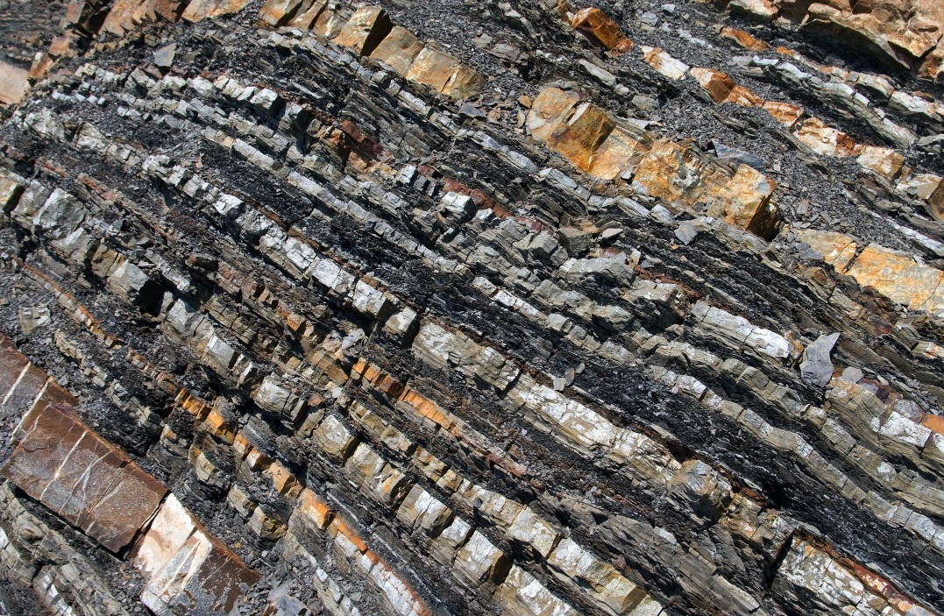 Foliation

URL: https://www.thoughtco.com/shale-rock-4165848
Protolith: Shale
- Phyllite (close up photo of rock)
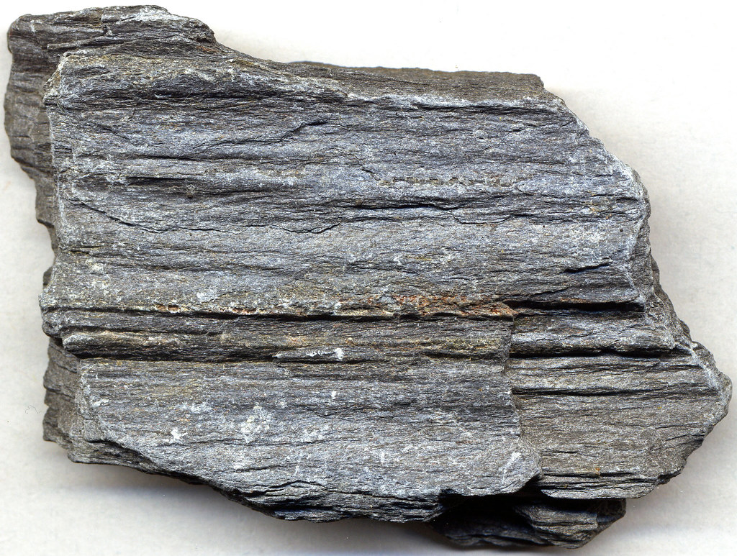 Foliation
URL: https://www.flickr.com/photos/jsjgeology/45625222381
Protolith: Slate
- Greenschist (close up photo of rock)
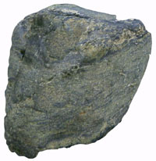 Foliation
URL: http://geologycafe.com/gems/chapter10.html
Protolith: Slate
- Blueschist (close up photo of rock)
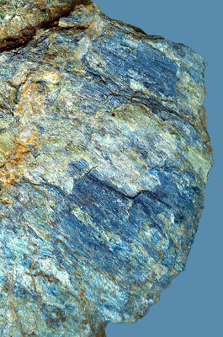 Foliation
URL: http://rxrocks.blogspot.com/2011/09/its-blue-its-schist-its-blueschist.html
Protolith: Basalt
- Orthogneiss (close up photo of rock)
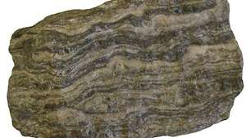 Foliation
URL: https://www.britannica.com/science/orthogneiss
Protolith: Granite
- Paragneiss (close up photo of rock)
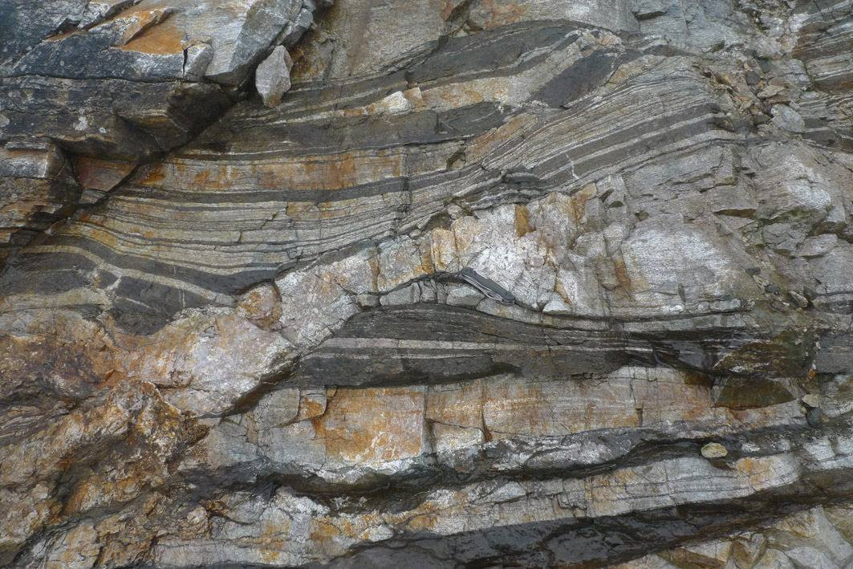 Foliation
URL: https://geologias.wordpress.com/2013/11/20/paragneiss/
Location: Found near Santander Massif, Colombia, South America
Protolith: Gneiss
- Stretched metaconglomerate (close up photo of rock)
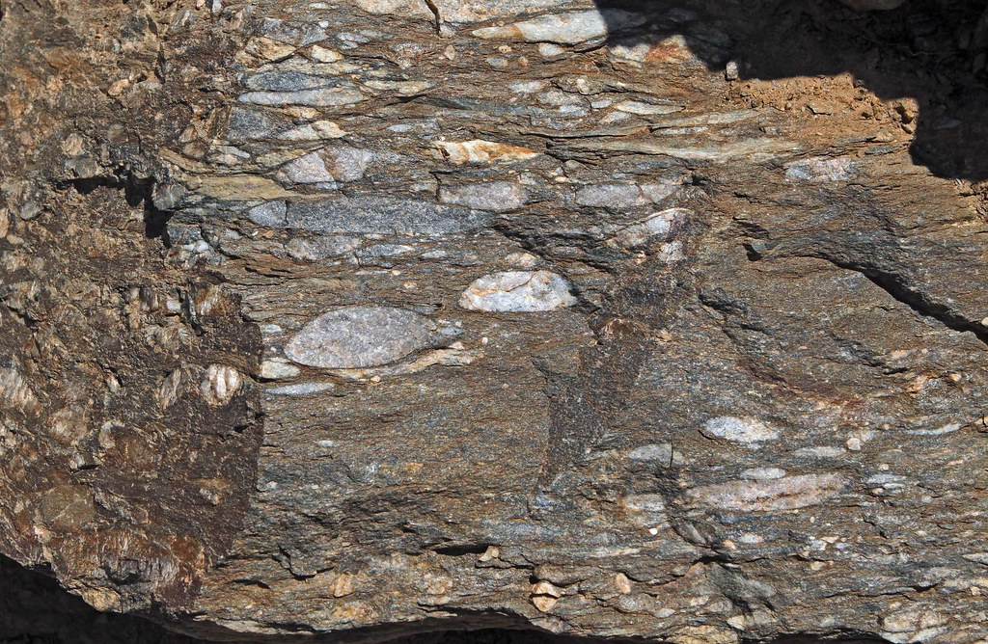 Foliation
URL: https://line.17qq.com/articles/nkppnhmdv.html
For each photo,
  - cite the url for the photo and location info if available
  - annotate the photo with labels or drawings indicating the foliation
  - name the protolith of the rock.

Rocks that have become DUCTILE are at temperatures and pressures where metamorphism will occur. Ductile structures such as folds (anticlines, synclines), boudins, and shear zones are often formed while rocks undergo metamorphic change. Not all folded rocks are metamorphic; some folded rock layers form close to the surface if the rock is weak sedimentary rock.

Part 2: Find one photograph of each of the following types of structures in metamorphic rocks. (12 points)
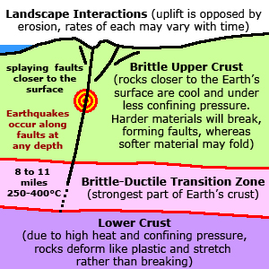
- Folding (close up photo of a rock)
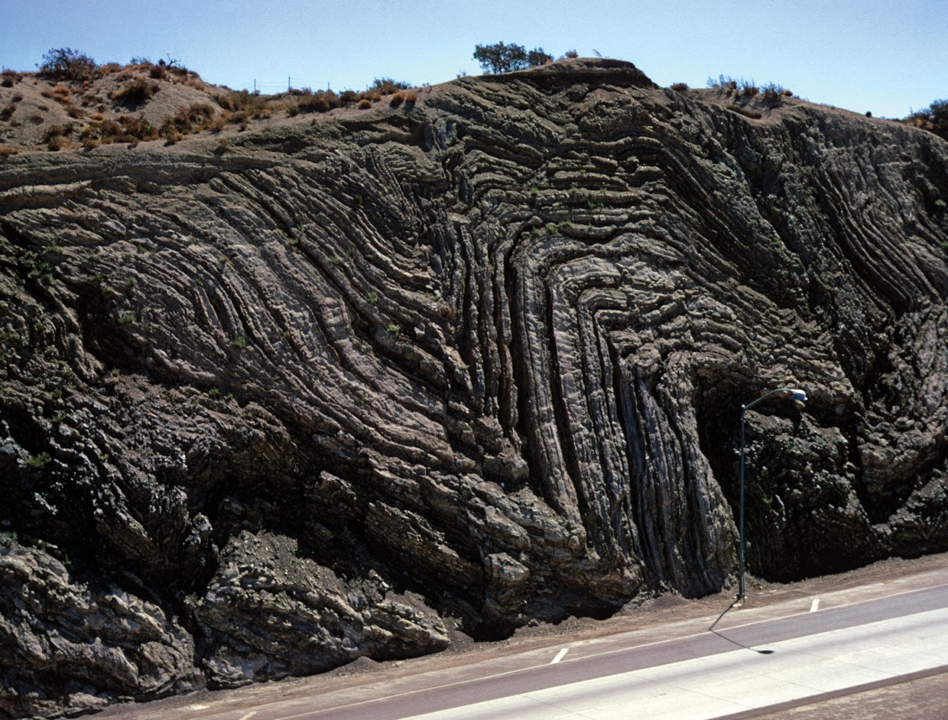
Limb
Syncline
Anticline
URL: https://cdn.britannica.com/s:690x388,c:crop/33/119233-050-240680F0/metamorphic-rock-highway.jpg
Rock type: Slate
Type of stress: Compression
- Boudinage (close up photo of a rock)
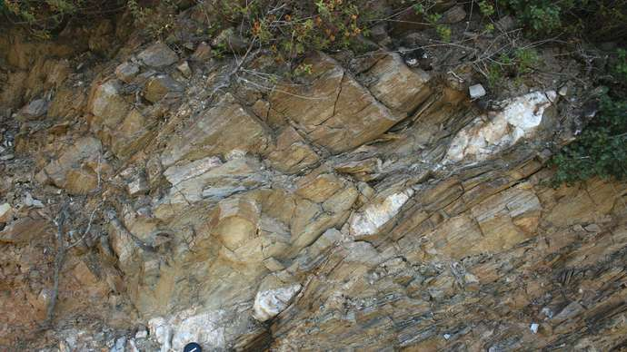
Mineral aggregates
Boudin
URL: https://cdn.britannica.com/s:690x388,c:crop/57/148057-050-61EC8975/vein-blueschist-quartz-Greece-Samos.jpg
Location: Samos, Greece
Rock Type: Blueschist
Type of stress: Extension
- Shear zone (close up photo of a rock)
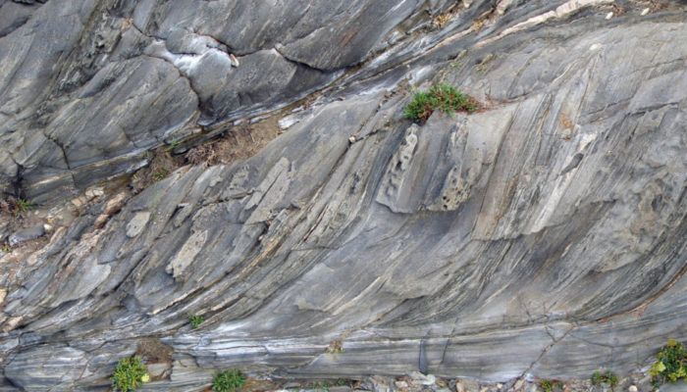 Rock under stress
Shear zone
Shear zone
URL: https://blogs.egu.eu/divisions/ts/2021/01/25/features-from-the-field-shear-zones-and-mylonites/
Metamorphic rock: Schist
Type of stress: Shearing stress
For each photo,
- cite the url for the photo and location info if available
- annotate the photo with labels or drawings indicating the structure
- name the type of metamorphic rock in the photo
- name the type of stress that caused this structure to form.
Nonfoliated metamorphic rocks form in a variety of ways. Hydrothermal metamorphism or metasomatism is when hot fluids with dissolved materials pass through rock and cause chemical reactions. Many economically valuable deposits of copper, gold, silver, and other metals are formed in this way. Another way is when the heat from magma or lava bakes the rock it touches, causing contact metamorphism. Another way is by regional metamorphism in which differential stresses are not significant enough to cause foliation to form.

Part 3: Find one photograph of each of the following types of nonfoliated metamorphic rocks. (33 points)
- Marble (close up photo of a rock)
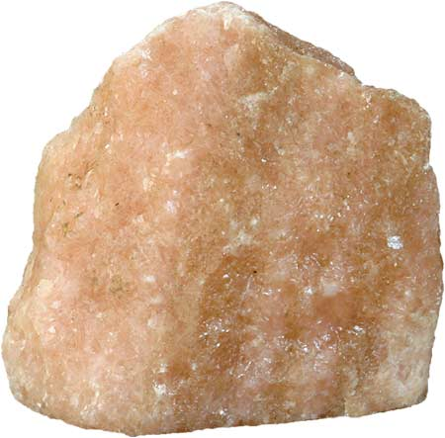
URL: https://flexiblelearning.auckland.ac.nz/rocks_minerals/rocks/images/marble3.jpg
Location: New Zealand, Northland (Marble Bay)
Protolith: Limestone
Contact metamorphism.
- Quartzite (close up photo of a rock)
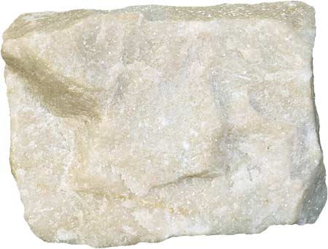
URL: https://flexiblelearning.auckland.ac.nz/rocks_minerals/rocks/images/quartzite2.jpg
Location: New Zealand, Northwest Nelson (Aorere)
Protolith: Sandstone
Regional and Contact Metamorphism.
- Hornfels (close up photo of a rock)
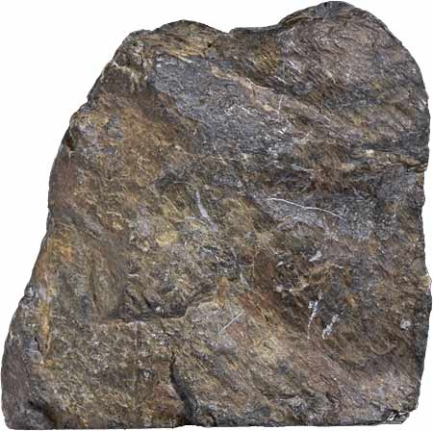
URL: https://flexiblelearning.auckland.ac.nz/rocks_minerals/rocks/images/hornfels1.jpg
Location: Whangarei Heads, Tokatoka (Kaipara area) in New Zealand
Protolith: Shale
Contact metamorphosim
- Greisen in place within its host rock
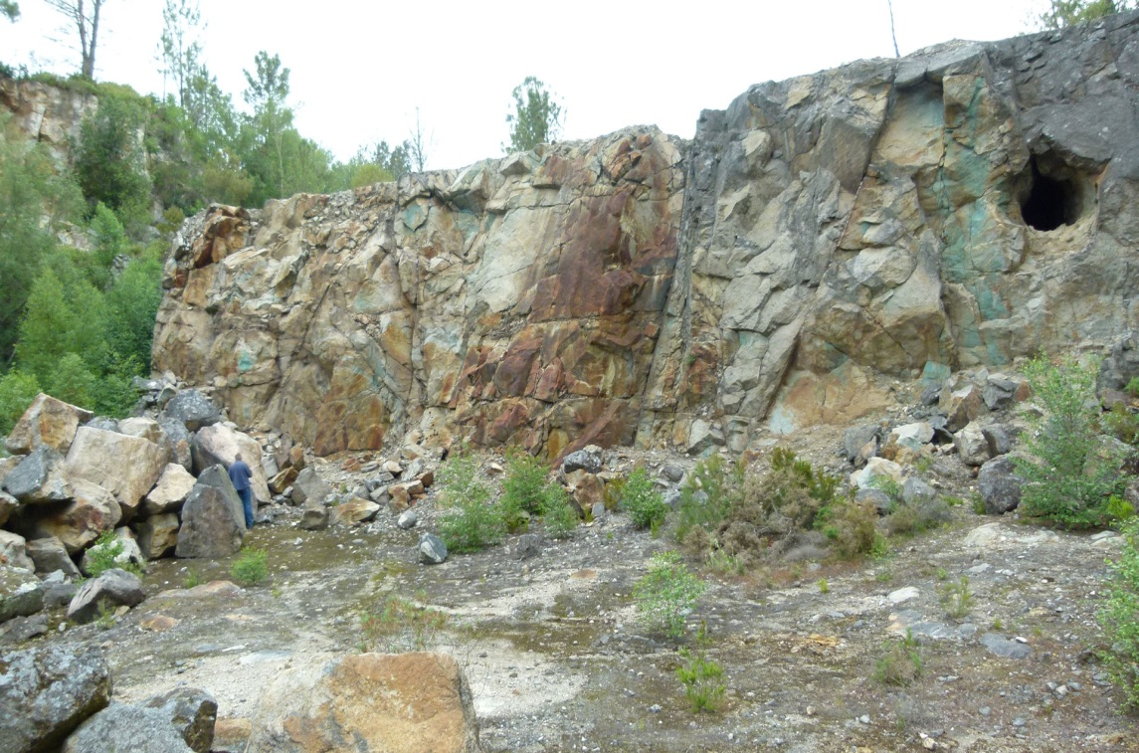 Greisen
URL: https://image.jimcdn.com/app/cms/image/transf/dimension=820x10000:format=jpg/path/s9bd16016353c2d5f/image/ic81136c4634418a6/version/1487599286/image.jpg
Location: Monte Neme W-Sn mine, Spain
Protolith: Granite
Hydrothermal Metamorphism.
- Skarn (close up photo of a rock)
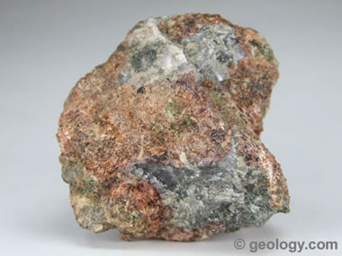
URL: https://geology.com/rocks/pictures/skarn.jpg
Protolith: Granite
Metasomatism
- Eclogite (close up photo of a rock)
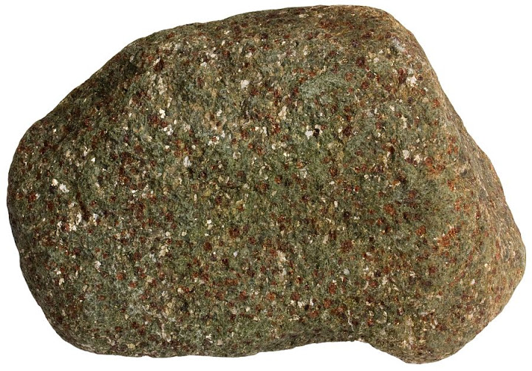
URL: http://lh3.googleusercontent.com/-Bbc306arrZo/VeqvCZ918XI/AAAAAAAAK4s/VVKSiWbgJQI/s720/1402%25252015.06.15_2%252520eclogite%252520mica%25252010%252520cm.jpg
Protolith: Peridotite
Regional Metamorphism
- Serpentinite (close up photo of a rock)
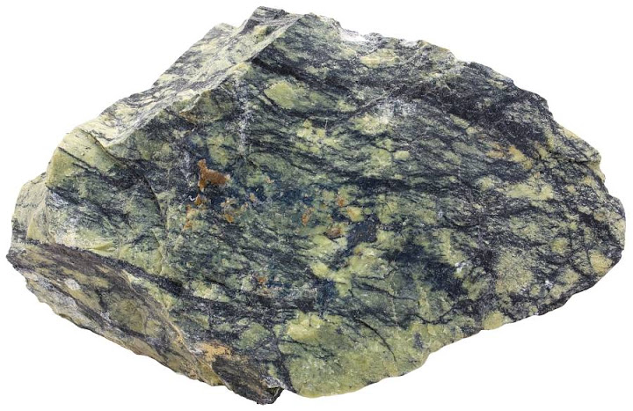
URL: http://lh3.googleusercontent.com/-JD-nz1oTjzA/Vf0Rc2P_MkI/AAAAAAAALjg/zo2fLu3pWI0/s720/1788%25252014.08.15_3%252520Tapuli%252520skarn%252520must%252520on%252520mittemagnetiline%252520roh%252520serpentine%252520vb%25252013%252520cm.jpg
Location: California's Santa Cruz Mountains
Protolith: Sandstone
Contact Metamorphism
- Amphibolite (close up photo of a rock)
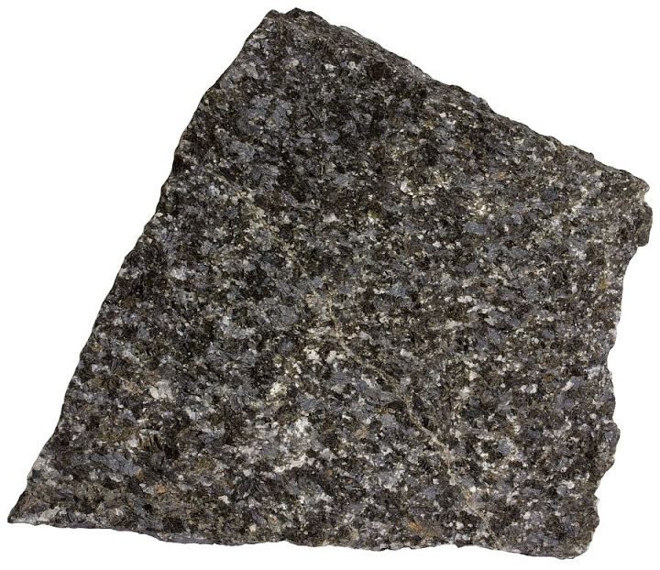
URL: http://lh3.googleusercontent.com/-RKcQKe25MpQ/Vequu5B8_aI/AAAAAAAAK1M/g5AWlpoHCfI/s720/1374%25252012.06.15_4%252520amphibolite%25252010%252520cm.jpg
Protoliths: Basalt, Gabbros and Sedimentary dolomite
Regional Metamorphism
- Charnockite (close up photo of a rock)
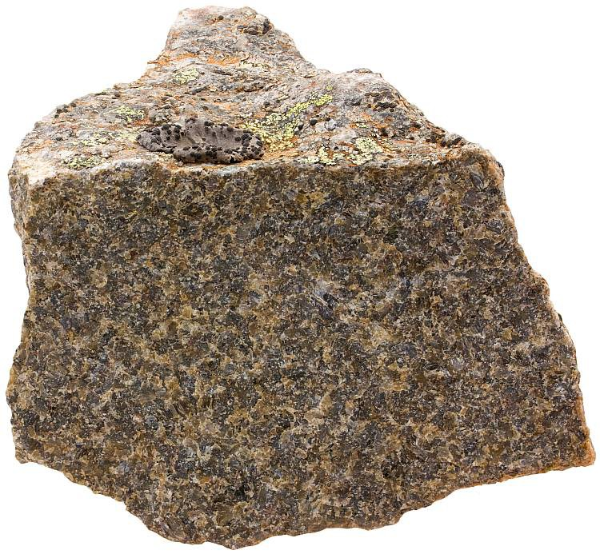
URL: https://www.sandatlas.org/wp-content/uploads/Charnockite-01619-750x693.jpg
Protolith: Granite
Regional Metamorphism
- Gold ore
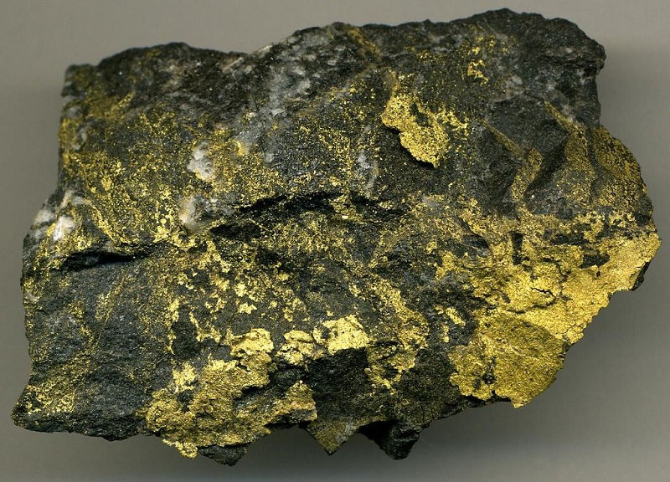
URL: https://www.mining-technology.com/wp-content/uploads/sites/8/2019/07/Red-Lake-Gold-Ore-1.jpg
Location: Russian gold field, the Sergeevskoe Gold Project
Protolith: Sedimentary rocks.
Contact Metamorphism
- Copper ore
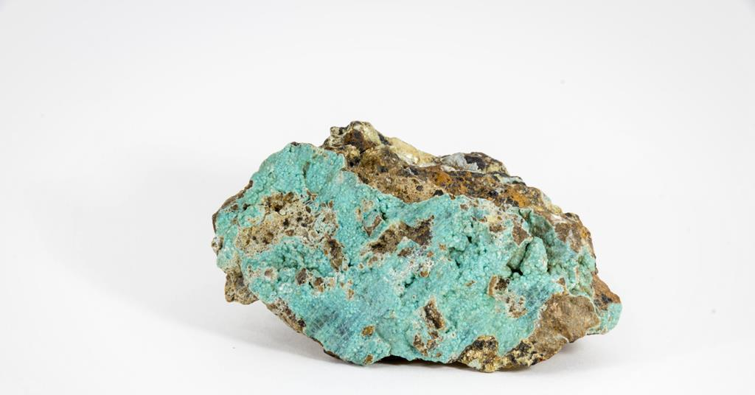
URL: https://d1ymz67w5raq8g.cloudfront.net/Pictures/1024x536/2/9/5/511295_copperore_shutterstock_599669738_322444.jpg
Protoliths: Igneous and sedimentary rocks
Contact metamorphism
For each photo,
- cite the url for the photo and location info if available
- name the protolith of the rock
- type of metamorphism: contact, regional, or metasomatism (hydrothermal)

The temperatures and pressures required to create different types or facies of metamorphic rocks with particular minerals in them has been worked out.

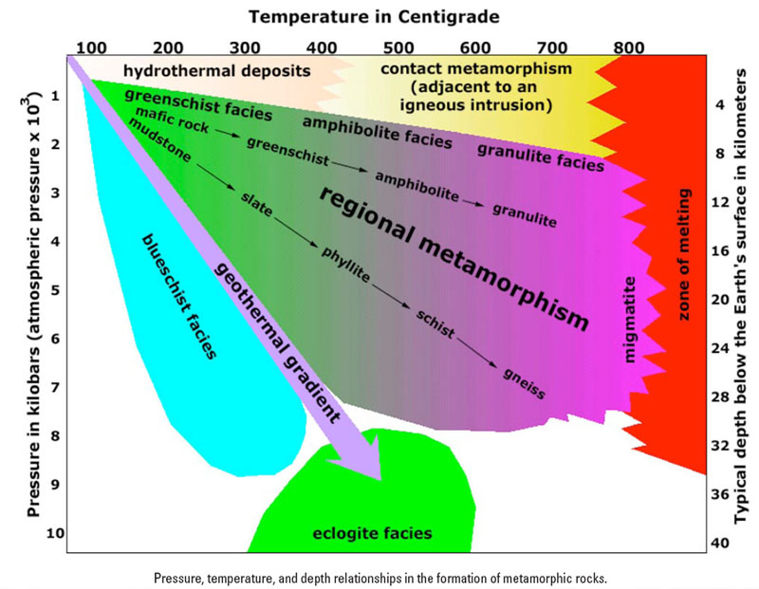

Part 4: Use the chart provided to answer the following questions. (10 points)
- Where can you find natural occurrences of glaucophane in California? Search this and select mindat.org sites for your research.
Berkeley Hills, Livermore Mining District (Tesla District), Clayton Mount Diablo (Mt Diablo), San Diego County, Diablo Range, Coast Ranges, Panoche.
- What is the age range of these rock glaucophane-bearing rocks?
The pre-Cretaceous Age (145 to 66 million years ago)
- Glaucophane is a mineral found in blueschist facies metamorphic rocks. Under what tectonic conditions do blueschist facies rocks form?
They are formed during subduction of a cold oceanic plate underneath a continent.
- What was the plate tectonic setting of California during the time these glaucophane bearing rocks formed?
The North American plate (on which modern day California is found) interacted with The Pacific Plate leading to the formation of Californian Mountains and subsequently the rocks
- The Mendenhall Gneiss is found in the San Gabriel Mountains, close to Glendale. It is a granulite-migmatite facies metamorphic rock. How many kilometers of uplift and erosion occurred to expose this rock? Give your answer as a range with a minimum and a maximum value.
3-4 kilometres.

Part 5: Try to use what you have learned to name the 7 metamorphic rock samples that are in the bag you were given. The samples are small—just try your best to identify them. (7 points) What you likely have in your bag are slate, phyllite, schist, gneiss, quartzite, marble and perhaps another example of schist, phyllite, or slate.
Photo of rock | Name of rock | Observations
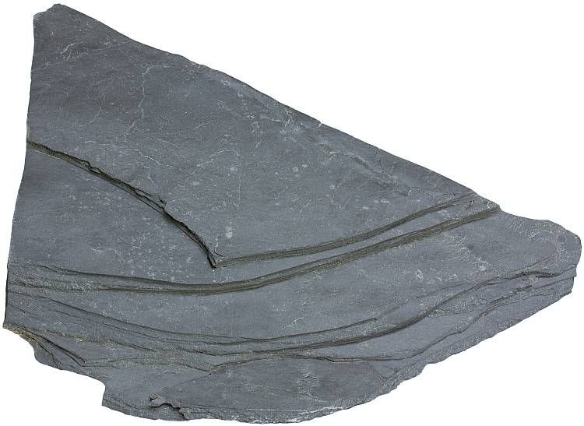 | Slate | It is fine-grained  It has foliations  Splits easily into thin slabs.  It is grey in color.  It is hard
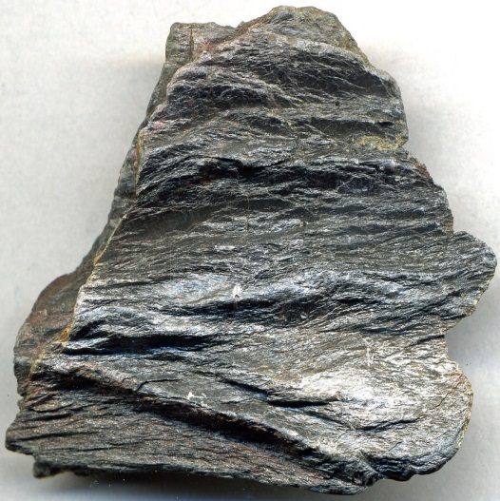 | Phyllite | Has foliations.  Grey in color  Its layers split easily  Fine-grained  Lustrous
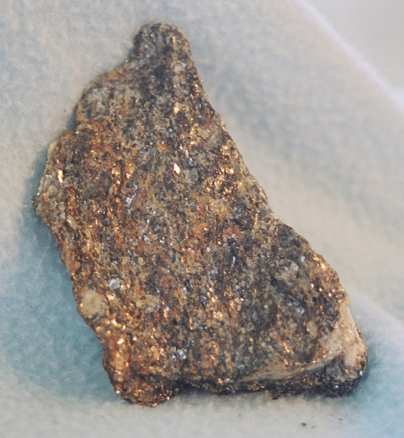 | Schist | Well-developed foliations  Medium-grained particles  Brown in color  Easily splits into pieces
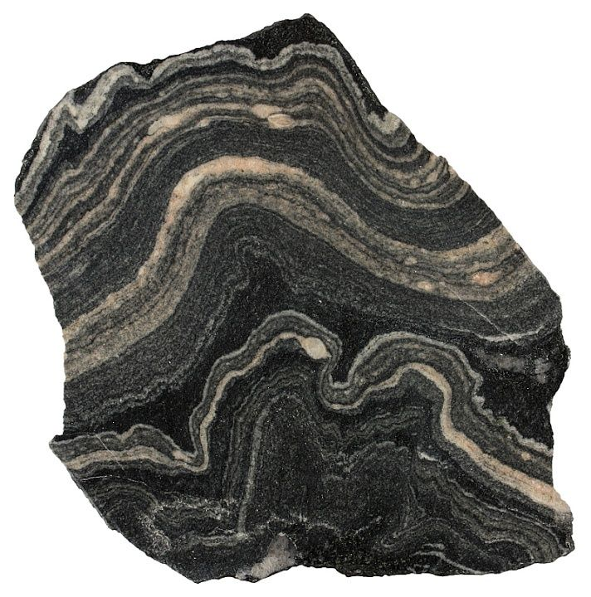 | Gneiss | Foliated  Banded appearance  Grey in color  Contains granular mineral grains
 | Quartzite | Hard  Granular in texture  Wide variety of color such as white and purple  Nonfoliated
 | Marble | Non-foliated  Hard  Medium grained  Color varies from white to pink and brown.
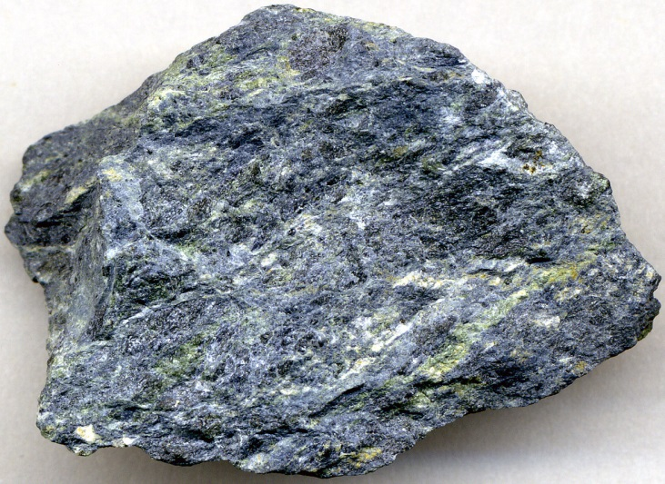 | Blueschist | Moderately foliated  Metallic blue color  Medium grained  Schistose texture

Reference
Geology of Gems. (2021). Retrieved 29 April 2021, from http://geologycafe.com/gems/chapter9.html

